**Top 5 Tennis games**

White uniforms, rackets, balls, nets, Do you remember something?

Yes, we are talking about Tennis! Extra exercise and running with time management and strategies, all of them are required to get a perfect score and winning in the Tennis games. Mobile tennis games require extra of all the efforts and techniques for enhanced experiences. Various skill sets are necessary for the same, and several pro gamers and players love playing tennis on their mobile devices. There are Tennis games available with 3D experience and realistic views to ensure extra pleasure and excitement.

Are you confused about the best choice for a Tennis game?

We have the top 5 Tennis games’ list with the best mechanics and features to ensure realistic experiences and energize the gamers with the best gaming. Here are the top Tennis games that are available for both Android and iOS users:

**Virtusa Tennis Challenge**

Virtusa Tennis Challenge is the highest rated one with the most number of fans and highest admirations. This game has several modes to ensure higher engagement like exhibition mode, multiplayer mode, and SPT World Tour mode. There is a swipe control feature that Virtusa provides for several shots to enhance the gameplay and activities. This game is also available for the casual game lovers as it has a simpler console with a decent user interface.

This game ensures more variety of experiences with 18 courts and 50 player features to switch in between. The environments can also be switched between clay court, grass court, hard court, and indoor court. There is also a training mode with the game that ensures proper learning of the consoles. 3D graphics is there too with realistic consoles for best experiences.

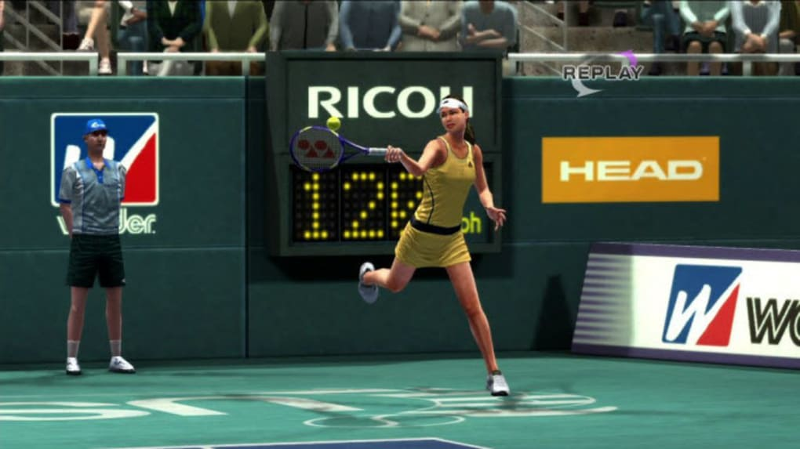

**Cross Court Tennis 2**

This is the tennis mobile game that has several technical mechanics to consider and is a perfect choice for the pro game lovers. This game has several on-court actions embedded to ensure better services and experiences. Cross Court Tennis 2 also has many consols and buttons for extra mechanics and features in the gameplay technique and has an appealing user interface and graphic for better playing. In this game, the players can also challenge each other.

Cross Court Tennis has a realistic appearance and experience with animations and high speeds. People can enter 15 global tournaments that are available with this game. Also, the 3D view ensures a higher level of excitement and energetic gameplay.

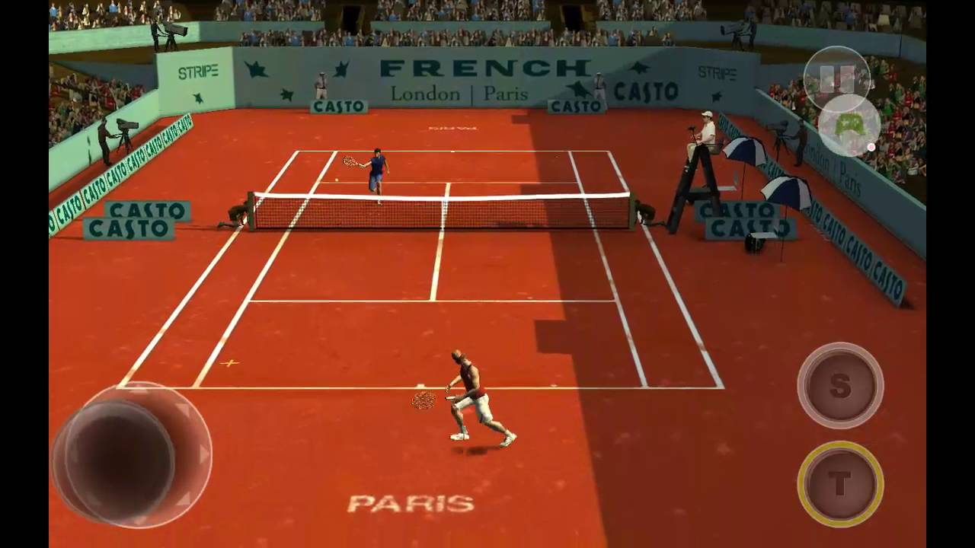

**Flick Tennis**

Flick Tennis is a simpler gaming application available for mobile devices and has several animations and story modes for extra entertainment. The game has a high-quality soundtrack with a narrative story structure that attracts millions of folks. This is the best application for a stress bursting and mind diverting with the facilities and mechanics offered. The game’s technique and consoles are pretty straight and easy which ensures higher user involvement and attractions.

This game also acquires a fan base due to the multiplayer gaming facility that it offers for competition lovers. Also, there are about 9 courts available to switch in between for enhanced experiences. This is the perfect choice of a tennis game for casual game lovers as well as the strategic players.

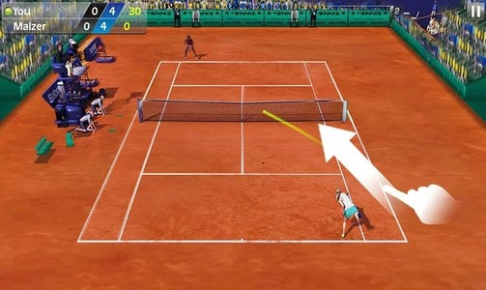

**Stick Tennis**

Stick Tennis is the perfect choice for the ones having busy and hectic schedules and those who want to have a few moments of relaxation and recreation. This is an easy and quick game with simple consoles and mechanics. This game focuses on the time mechanics rather than the strategic one that makes it more addictive. Graphics of the game are also pretty cool and decent that makes it act as the best recreational platform.

The game also provides a list of the players that you can choose to be your avatar. There are 70 players and 10 courts to switch in between. Stick Tennis has a feature of daily challenges that provides several trophies, and this everyday update ensures a higher fanbase for the game.

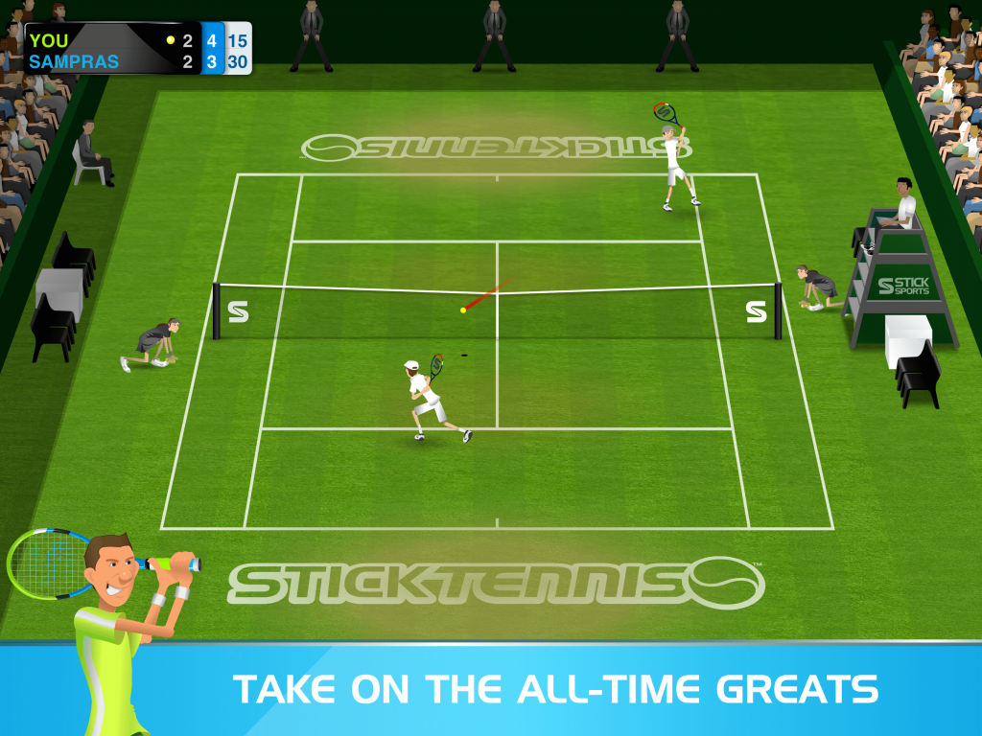

**Tennis Club story**

The interface of the Tennis Club story is simple with easy accessibility. This application is launched by Kairosoft who specializes in releasing management games.

This is a perfect application for training and competitive practices. There is a customizable training manual available in the application to set the required targets. In this application, you can select the best-suited sponsors and create your tennis clubs and organize pieces of training and events with this application. There are mini-games available too that ensure its reach even to the workaholics. This is a paid application. For the lesser complexity lovers, this is the best choice.

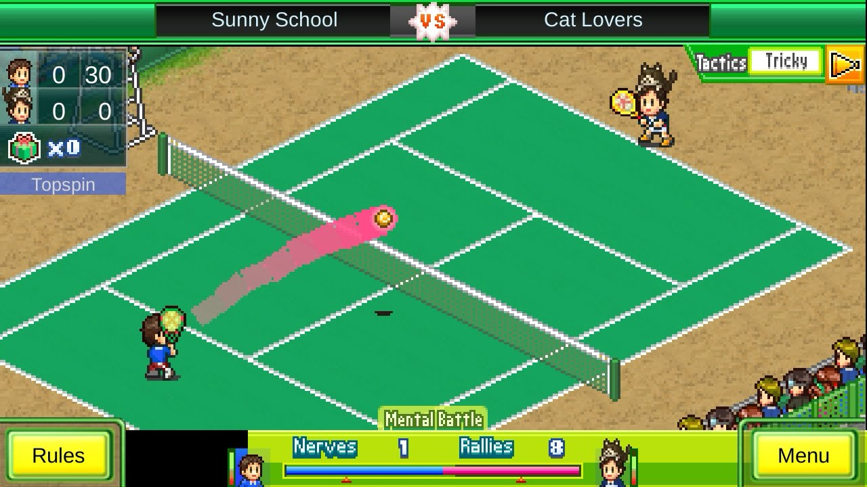

**Tennis game development**

Tennis games come in a variety from realistic graphics to cartoon ones. With several varieties and designs, the game app studio provides the best quality for the tennis game apps. For training purposes, learning, to competitive gaming and team making, we provide several features to make a tennis game the top gaming application worldwide. The developer team of game app studio understands the user requirements and design the application to embed every single feature asked by the clients. We work to meet client satisfaction, and also provide services for the game management and update developments.